Signal and System Project

**Project Title:** M*easure the dimension of an Object within an 2D image and determining the shape of the object.*

**Group Member:**

|  |  |
| --- | --- |
| **Name** | **Roll Number** |
| Jap Purohit | AU1940109 |
| Purvam Sheth | AU1940151 |
| Nihar Patel | AU1940119 |
| Raj Gariwala | AU1940118 |
| Mohit Prajapati | AU1940171 |

**Project Description:**

Measuring objects within an image or frame can be an important capability for many applications where computer vision is required instead of making physical measurements. This application note will cover a basic step-by-step algorithm for isolating a desired object and measuring its diameter/dimension. It will also try to determine the 2D shape it has. This application can be used in determining the dimension and shape of space objects using the 2D image we are available with.

**Programming language to be used:**

1. MATLAB for image processing
2. Python to provide user interface.

**Description of user interface:**

It will majorly allow user to provide the path of the image and at last the result will be showed determining the 2D shape and dimension of the object. The interface will be developed using the Python.

**The format of results expected to be obtained:**

**Input:**

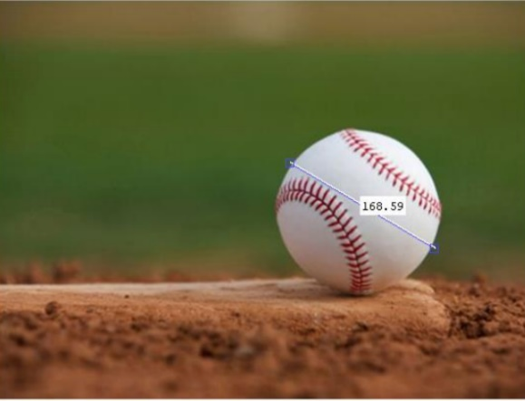

**Output:** The diameter of the object within object. And the shape as circle